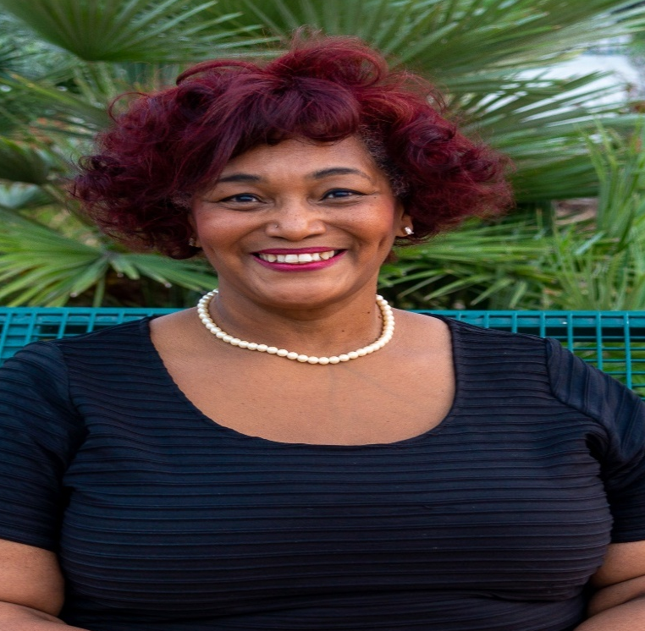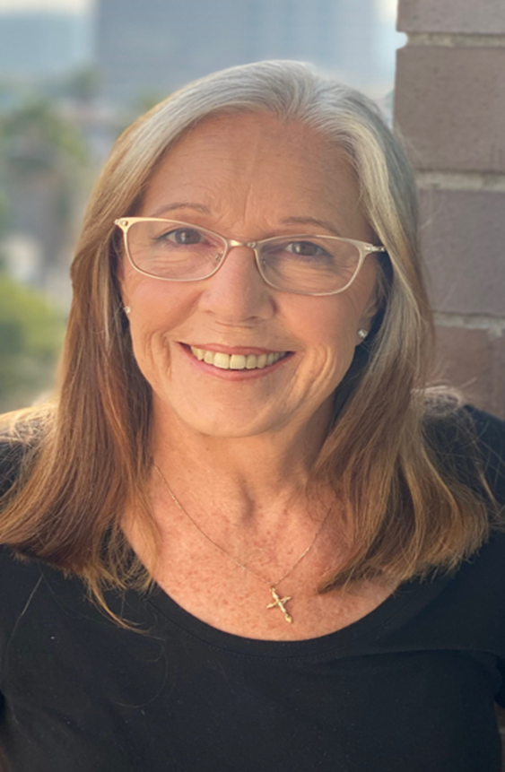

Give Children the Education They Deserve!
√ ELECT √
Dr. Monica Hinton
CAJON VALLEY USD, SCHOOL BOARD
TRUSTEE, AREA 4

I understand first-hand the struggles and sacrifices of being an educator as I have seen my own family and their friends, fellow administrators meet the challenges of being educators and organizational administrators at all levels. Choosing me is a choice for equity where teaches have a voice, reallocation of funds to meet the needs for healthy meals for all students and safe environments for learning. I am proud to be endorsed by the East County Democratic Club.
https://drmonicahinton.com/

√ ELECT √
Stacie Hoover
CAJON VALLEY USD, SCHOOL BOARD
TRUSTEE, AREA 5
A native of San Diego and a product of East County Schools, I have more than 40 years of experience with Cajon Valley Schools. I am currently serving on the School Site Council at Bostonia Elementary. I believe in safe schools, full time nurse at each school, and delicious nutrition for all students. “All students should have the education and tools to succeed in life.” I am proud to be endorsed by the Cajon Valley Education Association.
https://staciehoover.com/

